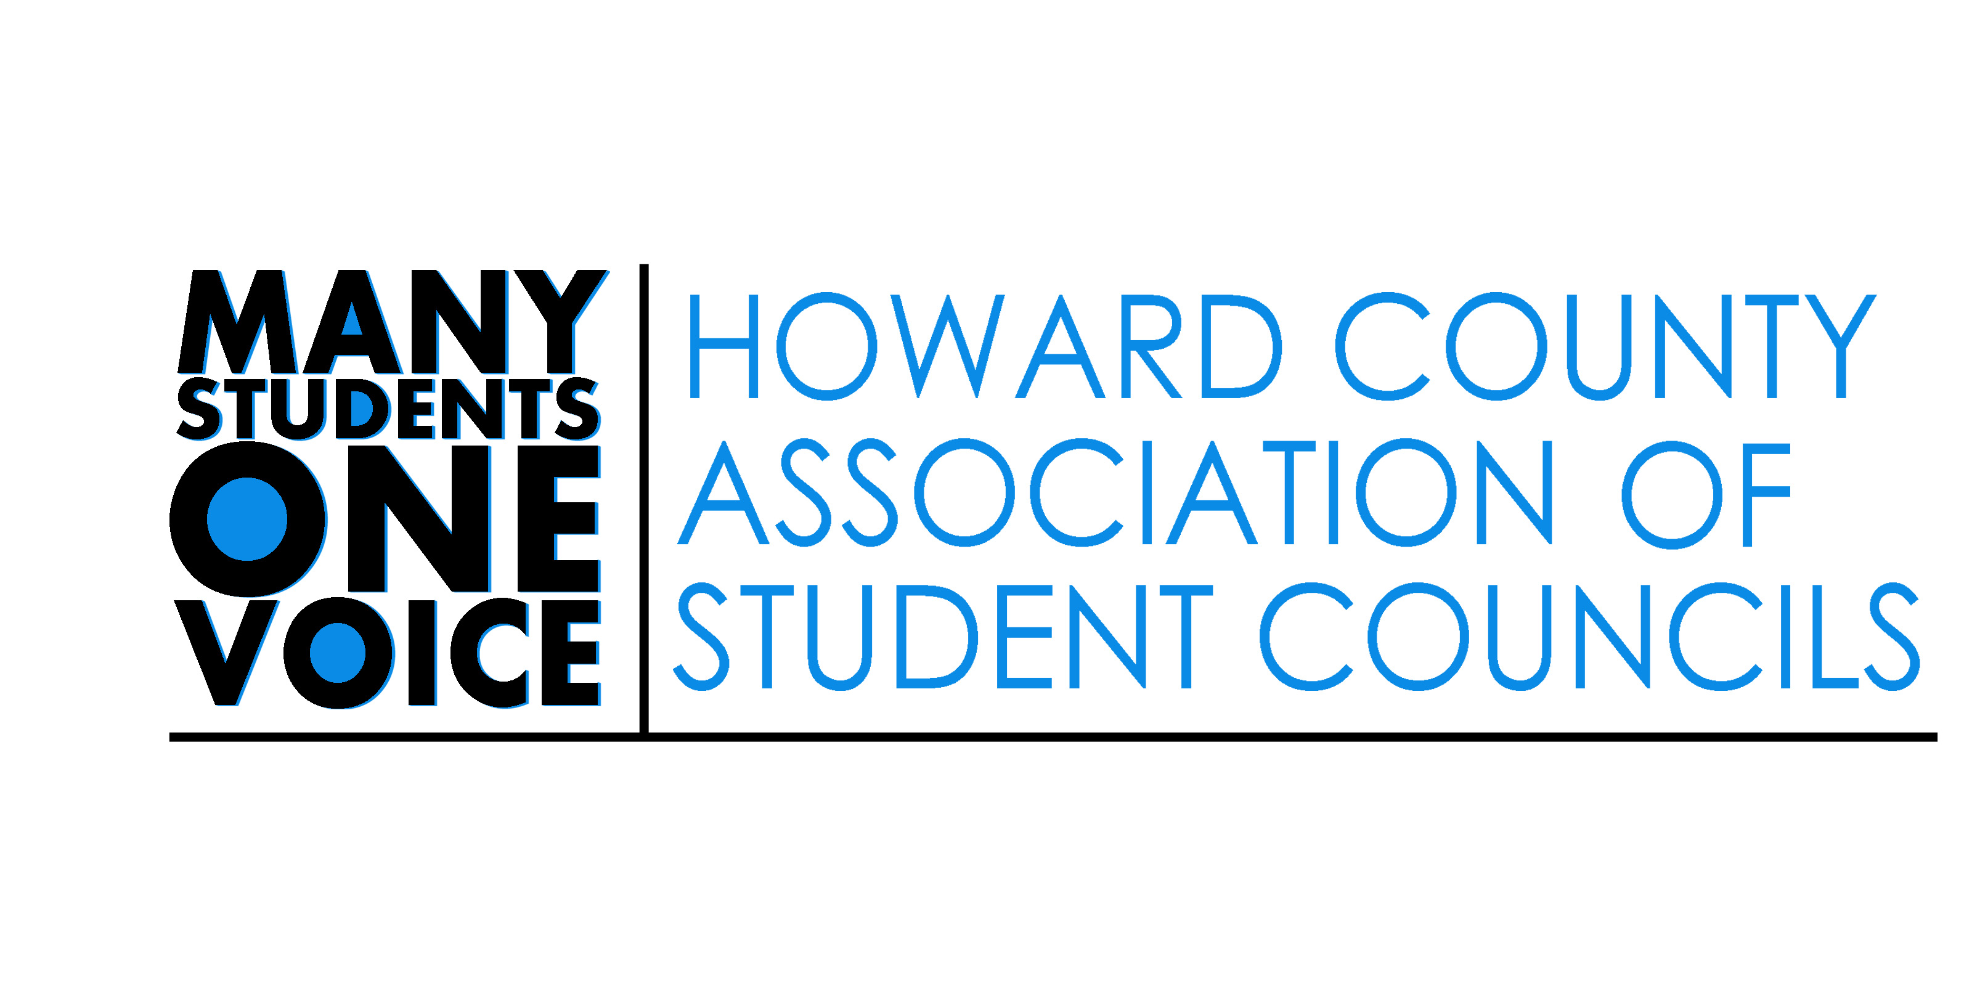
Appointed Positions Application Process
To apply for an appointed position:
- Send a cover letter which
  - states the position(s) you wish to hold
  - describes why you would like to serve in that position.

- Attach a resume to cindy_drummond@hcpss.org by 4:00 pm May 22, 2019

- Prepare for your interview
  - Think about why you want to serve as an HCASC Appointed Officer
  - Connect your previous experience to how you will serve as an Appointed Officer
  - Describe why you want to participate in HCASC and leadership at the county level.

Appointed Positions Application Schedule

May 22 Cover letters and resumes must be received by Mrs. Drummond by 4:00 p.m.
June 5 Interviews 3:00-6:00 You will be notified of the time you will be interviewed for an appointed position.

HCASC APPOINTED POSITIONS 2019-2020

Second Vice President (middle school students only).
- Assist the vice president in all matters, and act as the representative of the middle school student body.
- Serve as an ambassador for middle school student leaders
- Reach out to middle school student leaders and encourage them to attend HCASC meetings
- Bring middle school student ideas and concerns to HCASC officer team and the Student Member
- Serve as an executive board member of MASC and attend all MASC meetings.
- Attend all HCASC General Assembly meetings

Chief of Staff
- Directly supervise all staff activity and ensure that all staff members complete their respective tasks
- Report all activity, progressive and problematic, to the HCASC Officers.
- Attend officer planning meetings, monthly GA meetings, the Student Voice Convention, and presentations to the Board of Education
Student Member Convention Coordinator(s):
- Work with the HCASC Advisor and the HCASC Officer Team to design, plan, and manage the county wide student convention to select the candidates for Student Member of the Board of Education
- Create training materials to prepare students to serve as informed delegates to the convention
- Conduct county wide and school-based training sessions for students
- Maintain a journal with suggestions and feedback for future Convention Coordinators
- Promote the Convention and Student Delegates
- Attend monthly appointed officer and GA meetings
- Provide own transportation for planning meetings, delegate training, and events throughout the school year

State Legislative Affairs Coordinator
- Chair the Legislative Affairs Committee which is responsible for researching bills in the state legislature pertinent to youth, represent HCASC and MASC, and lobby policy makers to inform them of HCASC’s positions on education and youth-related bills.
- Coordinate countywide lobbying efforts and plan countywide lobbying events
- Coordinate with Student Member to promote student attendance and participation in Board of Education meetings
- Create monthly reports for the HCASC meetings
- Attend monthly appointed officer meetings and GA meetings

Health and Social Issues Coordinator(s):
- Promote awareness of health and social issues and provide leadership for HCASC initiatives
- Research and share state and county regulations and statutes regarding Safe Schools Initiatives, Mental Health, Discrimination, and Bullying/ Harassment policies
- Build relationships with school clubs and community groups to promote environmental related activities and opportunities for HCASC
    - reach out to school clubs and community groups to promote environmental related activities and opportunities
    - bring ideas and concerns from county wide groups back to HCASC and the Student Member
- Organize countywide community service projects
- Create monthly reports for the HCASC meetings
- Attend monthly appointed officer meetings and GA meetings

Environmental Affairs Coordinator(s):
- Serve as the chair of the Environmental Affairs Committee
- Engage in environmental issues and promote environmental related opportunities
- Build relationships with school clubs and community groups to promote environmental related activities and opportunities for HCASC
    - reach out to school clubs and community groups to promote environmental related activities and opportunities
    - bring ideas and concerns from county wide groups back to HCASC and the Student Member
- Create monthly reports for the HCASC meetings
- Attend monthly appointed officer meetings and GA meetings
Public Relations Manager(s):
- Manage the HCASC web page and social media in partnership with the HCASC advisor and Corresponding Secretary
- Continually work to improve the communications between HCASC and the member schools not only through the website, but through newsletters, social media and other publications.
- Hold responsibility for working with and contacting with executive board members in order to process the correct information.
- Work with the HCASC Officer Team and the HCASC Advisor to promote HCASC information
- Create monthly reports for the HCASC meetings
- Attend monthly appointed officer meetings and GA meetings
- Promote and support the Student Member of the Board

Special Elections Coordinator:
- Organize and monitor the annual elections of the Student Member of the Board of Education.
- Oversee all HCASC elections including the annual election of officers, unless there is a clear conflict of interest
- Monitor the ballot counting procedure.
- Create monthly reports for the HCASC meetings
- Attend monthly appointed officer meetings and GA meetings

STEM Coordinator:
- Qualification and appointment: The coordinator shall create a system to promote STEM related activities and opportunities.
- The administrator shall reach out to school clubs and community groups to promote STEM related activities and opportunities.
    - reach out to school clubs and community groups to promote Arts related activities and opportunities
    - bring ideas and concerns from county wide groups back to HCASC and the student member
- Create monthly reports for the HCASC meetings
- Attend monthly appointed officer meetings and GA meetings

Arts Coordinator:
- Qualification and appointment: The coordinator shall create a system to promote Arts related activities and opportunities.
- The administrator shall
    - reach out to school clubs and community groups to promote Arts related activities and opportunities
    - bring ideas and concerns from county wide groups back to HCASC and the student member
- Create monthly reports for the HCASC meetings
- Attend monthly appointed officer meetings and GA meetings

Parliamentarian:
- Update the HCASC Constitution.
- Assist HCASC Officer Team to draft by laws and rules of order
- Attend monthly appointed officer meetings and GA meetings

