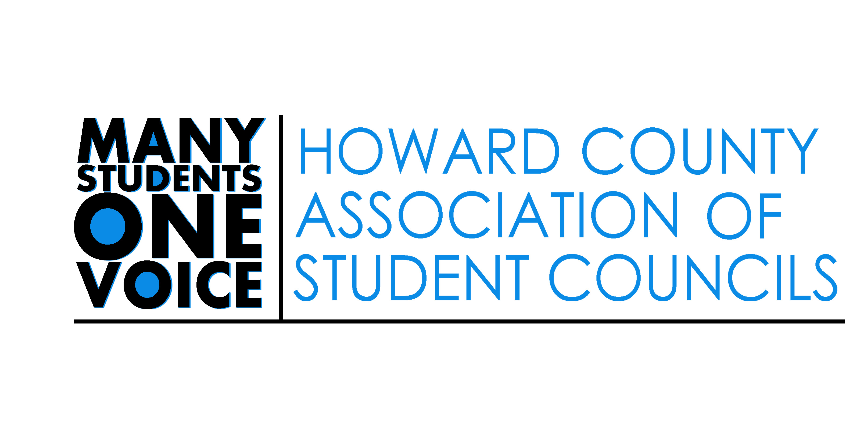

HCASC Elected Positions 2019

Howard County Association of Student Councils
Advisor –Mrs. Cindy Drummond

President – Mr. Alex Eapen

Introduction
The Howard County Association of Student Councils provides a unique opportunity for students to serve as effective leaders and role models for their peers as elected and appointed officers.

Goals of HCASC
The Howard County Association of Student Councils is an organization that focuses on creating a positive school environment, where leadership, service, and spirit are valued. Goals of HCASC include to empower students to
- Develop leadership skills
- Serve as the “go to” student organization of Howard County
- Provide student insight and feedback to the Howard County Public School System
- Collaborate with student leaders from across the Howard County Public School System

Elected Positions
The elected positions shall be elected by the students of Howard County.
President
First Vice President
Corresponding Secretary
Recording Secretary

Qualifications, Elections, and Term of Office of HCASC Officers

Qualifications:
A. The president, first vice-president, corresponding secretary, and recording secretary must be enrolled in a Howard County secondary school at the start of the ensuing school year.
B. Candidates must meet quarterly Howard County extra-curricular requirements.
C. Candidates for the office of president, first vice-president, corresponding secretary, and recording secretary must have attended at least five HCASC General Assembly Meetings in the school year in which they run prior to the HCASC elections.
D. Students who did not attend 5 HCASC meetings in the school year may request special consideration from the advisor and HCASC president. 250 words due to cindy_drummond@hcpss.org by 4:00 4/15.
E. No person shall serve as an HCASC officer while concurrently serving as the student member on the board in the year of his/her term.

Elected Officer Duties Include

President:
- Chair all meetings of the General Assembly and of the Executive Board;
- Govern all meetings using Robert's Rules of Order, Newly Revised, (unless specified otherwise by the President or an Officer presiding as the president)
- Review and revise the bylaws prior to the first Executive Board meeting;
- With the assistance of the advisor, appoint all staff members listed in bylaws;
- Serve as the official spokesperson for HCASC;
- Report on current HCASC activities at all General Assembly meetings;
- Report at the General Assembly meeting at the end of the year concerning the state of HCASC;
- Serve as the official representative of HCASC to the Maryland Association of Student Councils;
- Determine the time and place of all Executive Board meetings;
- Prepare the agenda for all Executive Board meetings;
- Notify the first vice-president in the case of inability to fulfill any of the above duties;
- Oversee all appointed staff and General Assembly Committees;
- Perform other duties outlined in the bylaws; and
- Perform other duties devolving from the office;
- Attend all HCASC officer planning meetings and HCASC General Assembly Meetings
- Attend Student Member of the Board Convention
- Attend Fall and Spring meetings of student leaders with the Board of Education members, Central Office Leaders, and student leaders from across the county
- Prepare and present to the HCASC Annual Report to the Board of Education and Superintendent

First Vice-President:
- Assume the duties and responsibilities of the president when he/she is unable to do so;
- Aid the president in fulfilling his/her duties and responsibilities;
- Perform other duties as outlined in the bylaws; and
- Perform other duties devolving from the office;
- Attend all HCASC officer planning meetings and HCASC General Assembly Meetings
- Attend Student Member of the Board Convention
- Attend Fall and Spring meetings of student leaders with the Board of Education members, Central Office Leaders, and student leaders from across the county
- Prepare and present to the HCASC Annual Report to the Board of Education and Superintendent

Corresponding Secretary
- include other related duties that the president or executive board may assign.
- Send notices of meetings to executive board members and association members, as directed.
- Read correspondence at executive board and association meetings
- Send social media/ e-mail updates as requested by officer team and appointed officers
- Direct, coordinate, maintain, and update the HCASC website and social media presence

Corresponding Secretary Continued
- Work with HCASC Public Relations Team members from middle and high schools to inform school communities about HCASC programs and events
- Attend all HCASC officer planning meetings and HCASC General Assembly Meetings
- Attend Student Member of the Board Convention
- Attend Fall and Spring meetings of student leaders with the Board of Education members, Central Office Leaders, and student leaders from across the county
- Prepare and present to the HCASC Annual Report to the Board of Education and Superintendent

Recording Secretary
- Maintain e-mail/ contact database of all HCASC members
- Maintain attendance rolls of all HCASC members
- Record officer meeting notes
- Record Pre-General Assembly and General Assembly meeting notes
- Manage and update SMOB Convention delegate contacts and canvas page
- Attend all HCASC officer planning meetings and HCASC General Assembly Meetings
- Attend Student Member of the Board Convention
- Attend Fall and Spring meetings of student leaders with the Board of Education members, Central Office Leaders, and student leaders from across the county
- Prepare and present to the HCASC Annual Report to the Board of Education and Superintendent

Voting Members and Procedures:
As per the HCASC Constitution, the voting members will be:
- HCASC executive board officers: President, Vice President, Treasurer, and Secretary
- 5 representatives from each high school who have attended at least three HCASC meetings within the last 12 months
- 3 representatives from each middle school who have attended at least three HCASC meetings within the last 12 months
Each school has the power to decide how their votes will be distributed. Should a school’s number of representatives exceed the number of votes, the school has the option to assign voters or to vote as a caucus and collectively determine how each ballot is marked.

If you have a question regarding the voting procedures do not hesitate to contact the HCASC President or Advisors.

On election day:
- Candidates for Vice President, Corresponding Secretary, and Recording Secretary will deliver a personal statement to the General Assembly not to exceed 2 minutes and will take part in a Question and Answer session not to exceed 10 minutes.
- Candidates for President will deliver a personal statement to the General Assembly not to exceed 3 minutes and will take part in a Question and Answer session not to exceed 10 minutes.

HCASC Elected Officer Application 2019

Send all completed application materials in an email to Mrs. Cindy Drummond cindy_drummond@hcpss.org
The application and signature page must be received no later than 4:00 pm on April 30, 2019.

- Elected Position Desired: _______________________

- Essay Question:

Write a personal statement explaining your qualifications for this leadership role with HCASC, including any past leadership experiences. Describe your vision/goals for this role and how you plan to execute your plans. Please keep essays to a one-page double-spaced maximum.

- Information

Student Name: __________________________________

Address: _______________________________________

Home Phone: ___________________________________

Cell Phone: _____________________________________

Email Address: __________________________________

School: ________________________________________

- Signatures: These required signatures ensure that you support all the goals of HCASC and understand the time commitment necessary to serve as an elected member of HCASC.

Student Signature: _____________________________

Parent Signature: ______________________________

Election Schedule

April 10 Election Applications will be available at the HCASC meeting and on http://hcasc.hcpss.org/

April 30 4:00 pm Elected Officer Applications due via email attachment to:
Mrs. Cindy Drummond cindy_drummond@hcpss.org

May 8 HCASC Elections will be held at the HCASC General Assembly meeting
Location: Homewood School (7:00 PM- 8:30PM)
Please note: Campaigning methods such as the handing out food and other
non-informational items will not be permitted.

